Asiqul Hoque

Lab2/Part1

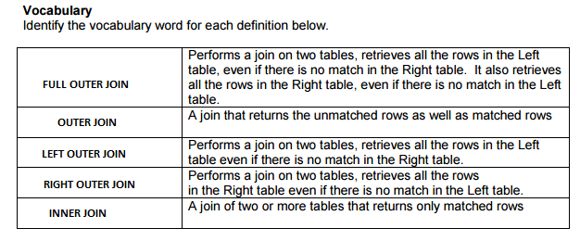

1.select e.first_name,e.last_name,d.department_name

FROM employees e LEFT OUTER JOIN departments d

on (e.department_id = d.department_id);

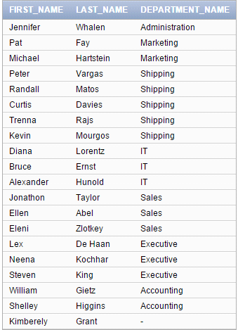

2.select e.last_name,e.last_name,d.department_name

FROM employees e RIGHT OUTER JOIN departments d

ON(e.department_id = d.department_id);

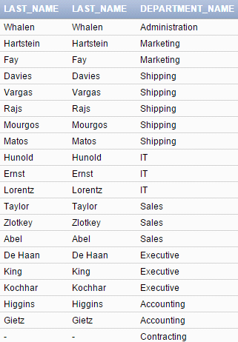

3.select e.last_name,e.last_name,d.department_name

FROM employees e FULL OUTER JOIN departments d

ON(e.department_id = d.department_id);

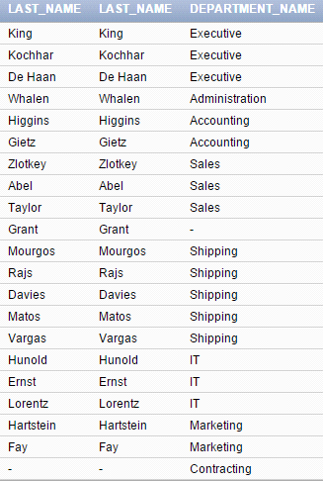

4.SELECT c.first_name, c.last_name, e.event_date, e.description

FROM d_clients c LEFT OUTER JOIN d_events e

ON(c.client_number = e.client_number);

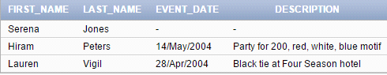

5.SELECT s.description, a.shift_assign_date

FROM f_shifts s LEFT OUTER JOIN f_shift_assignments a

ON (s.code = a.code);

